**Topic:** Book Recommendation (Machine Learning)

**Name:** Shivam Vishwakarma

**Roll no:** 6709

**Book Recommendation System**

A book recommendation system is an intelligent system designed to suggest books to users based on their interests, preferences, and past behavior. Since large online platforms (like Amazon or Goodreads) contain millions of books, users often find it difficult to choose what to read next. Recommendation systems solve this problem by automatically identifying and ranking books that are most relevant to each user.

**Types of Recommendation Systems**

1. **Content-Based Filtering**

* Uses book features such as title, author, genre, or description.
* Example: If a user likes “The Hobbit”, recommend other fantasy books by J.R.R. Tolkien or similar authors.

1. **Collaborative Filtering**

* Uses user behavior (ratings, interactions) instead of book features.
* Two main types:
  + **User-based CF:** Finds users with similar tastes and recommends books they liked.
  + **Item-based CF:** Finds books that were rated similarly by many users (used in your model).

1. **Hybrid Systems**

* Combine both content-based and collaborative filtering to overcome limitations of each.
* Example: Recommend books similar in genre and also highly rated by similar users.

**How our model works**

In this project, I used an Item-Based Collaborative Filtering approach with K-Nearest Neighbors (KNN):

* I built a User–Item Matrix where rows = users and columns = books (ISBN).
* Each book is represented as a vector of user ratings.
* Using cosine similarity, we measure how similar two books are based on user ratings.
* For a given input book, the model finds the k most similar books and recommends them.

**Data Set**

Books.csv

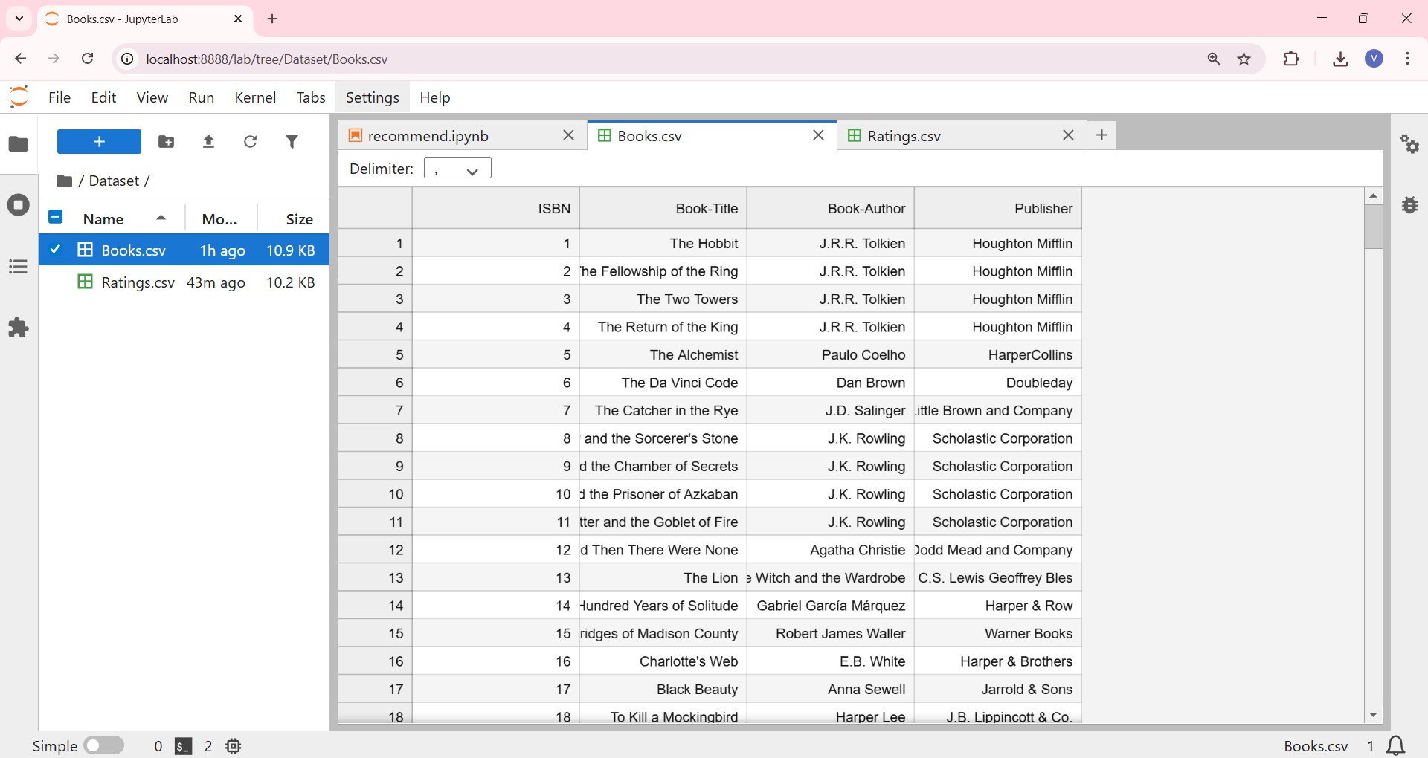

Ratings.csv

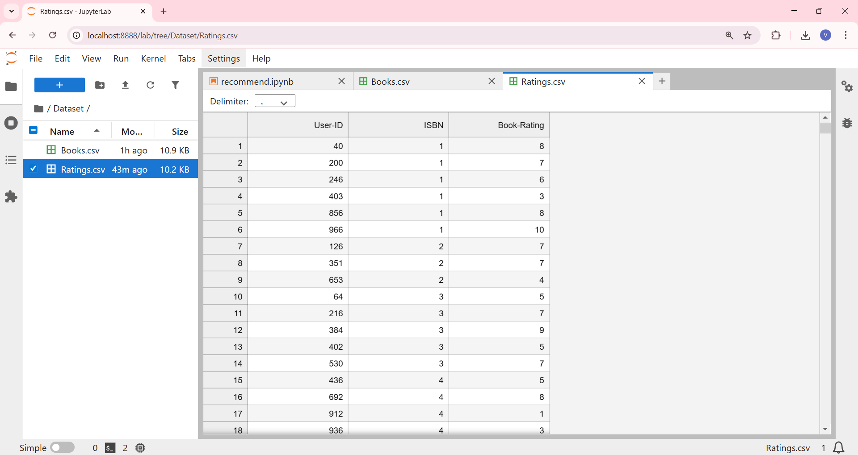

Step 1: Importing required libraries

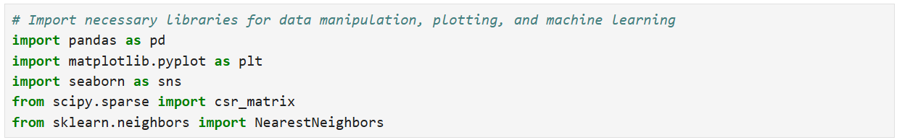

Step 2: Loading the Dataset and checking the dimension of data

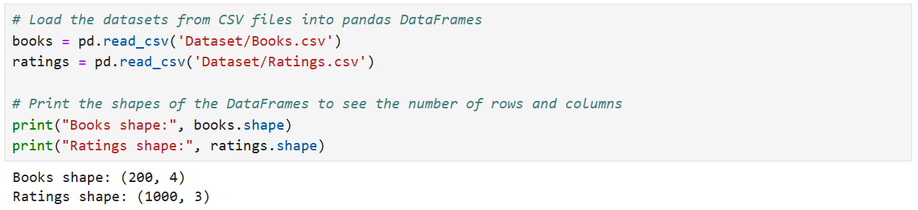

Step 3: Analysing the Data

1. Ratings distribution of Books: Majorly books have been rated 6, 7 and 8

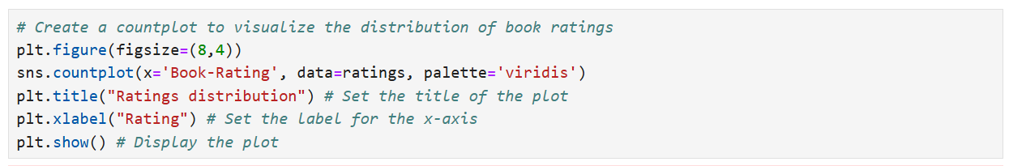

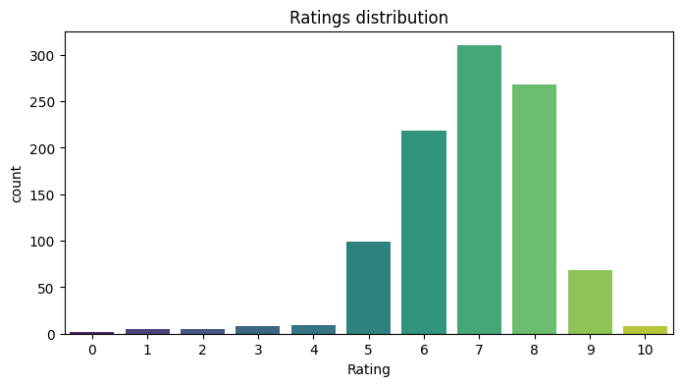

1. Top 10 most rated books

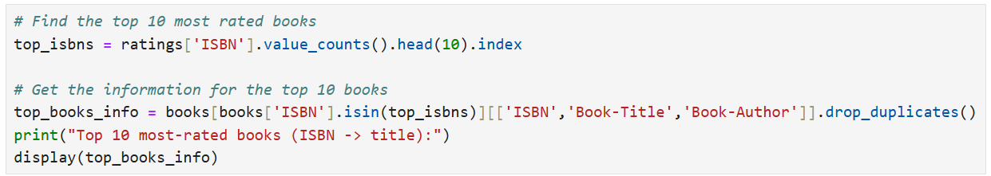

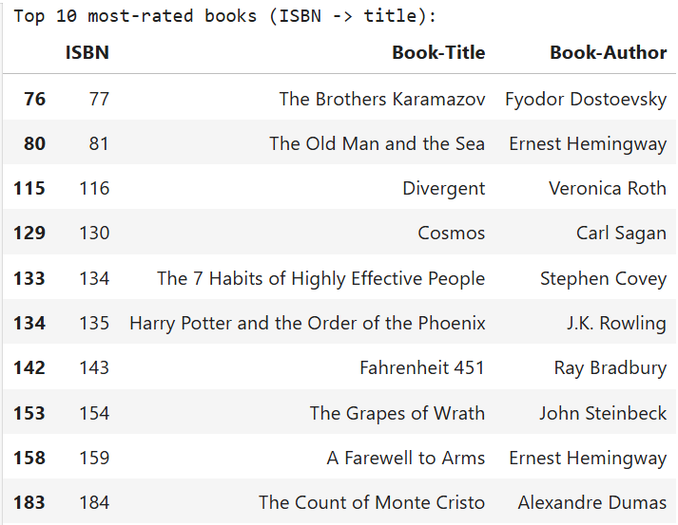

1. Most Books by Author

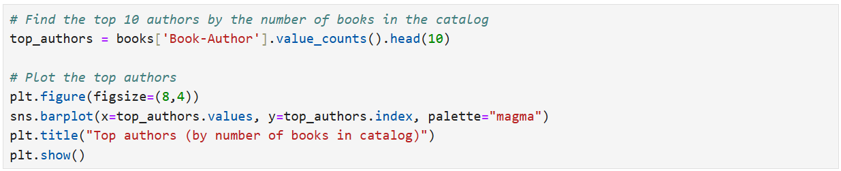

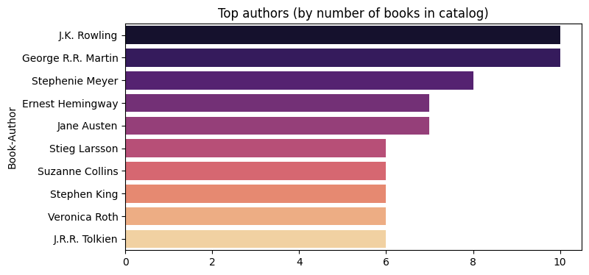

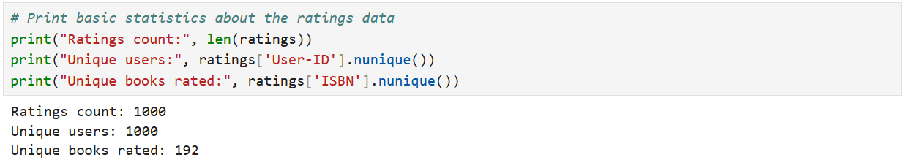

Step 4: Building Model & training the model

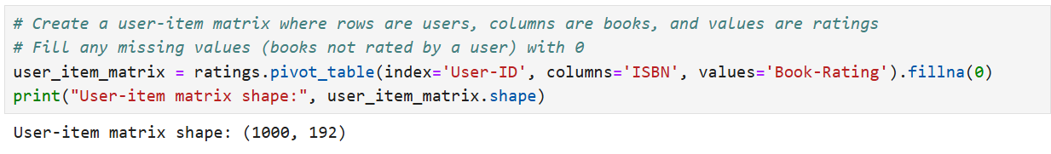

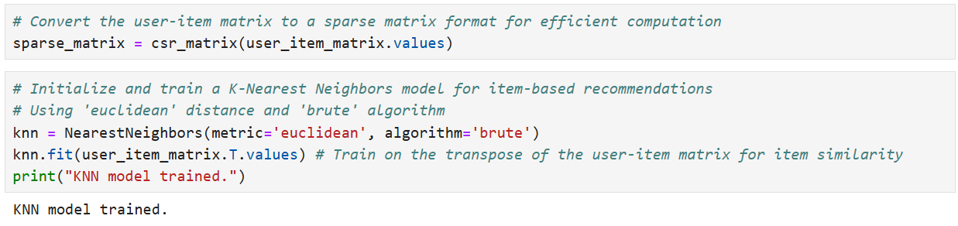

Step 5: Defining function to get recommended book.

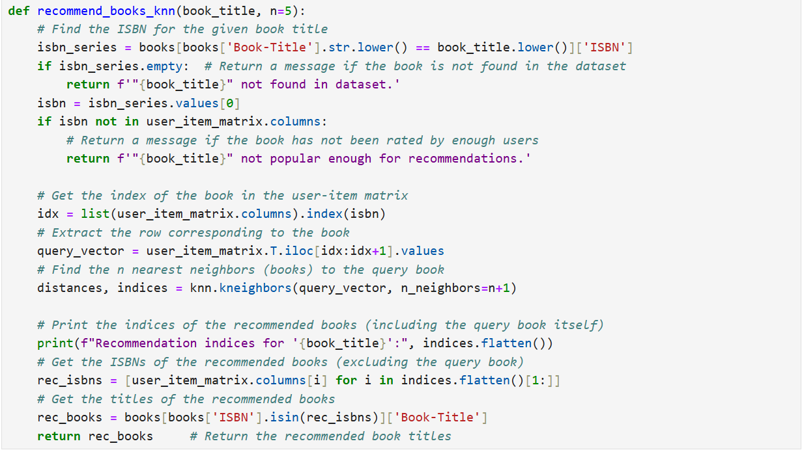

Step 6: Checking 5 recommendation for book “A Game of Thrones”

